Federation of Golden Flatts and Lynnfield Primary Schools

Year 2 - Autumn | Year 2 -Spring | Year 2 - Summer
Expected Standard
Number: Place Value | Statistics | Geometry: Position and Direction
- Read and write numbers to at least 100 in numerals and in words.  - Recognise the place value of each digit in a two digit number (tens, ones).  - Identify, represent and estimate numbers using different representations including a number line.  - Count in steps of 2, 3 and 5 from 0, and in tens from any number, forward and backward.  - Compare and order numbers from 0 up to 100; use <, > and = signs. | - Interpret and construct simple pictograms, tally charts, block diagrams and simple tables.  - Ask and answer simple questions by counting the number of objects in each category and sorting the categories by quantity.  - Ask and answer questions about totalling and comparing categorical data. | - Use mathematical vocabulary to describe position, direction and movement including movement in a straight line and distinguishing between rotation as a turn and in terms of right angles for quarter, half and three-quarter turns (clockwise and anti-clockwise).  - Order and arrange combinations of mathematical objects in patterns and sequences
Number: Addition and Subtraction | Geometry: Properties of Shape | Problem Solving and Efficient Methods
- Add and subtract numbers using concrete objects and pictorial representations and mentally , including a 2digit number and ones.  - Add and subtract numbers using concrete objects and pictorial representations and mentally , including a 2digit number and tens.  - Add and subtract numbers using concrete objects and pictorial representations and mentally , including 2, 2digit numbers.  - Add and subtract numbers using concrete objects and pictorial representations and mentally , including adding 3 one digit numbers.  - Solve problems using concrete objects and pictorial representations, applying their increasing knowledge of both mental and written methods.  - Solve problems using concrete objects and pictorial representations, including those involving numbers, quantities and measures; applying their increasing knowledge of both mental and written methods.  - Show that the addition of two numbers can be done in any order and subtraction of one number from another cannot.  - Recognise and use the inverse relationship between addition and subtraction and use this to check calculations and solve missing number problems. | - Name, identify and describe the properties of 2-D shapes, including the number of sides and line symmetry in a vertical line.  - Name, identify and describe the properties of 3-D shapes, including the number of edges, vertices and faces and the shape of those faces.  - Compare and sort common 2-D and 3-D shapes and everyday objects.  - Order and arrange combinations of mathematical objects in patterns and sequences | - Use place value and number facts to solve problems.  - Recognise and use the inverse relationship between addition and subtraction and use this to check calculations and solve missing number problems.  - Solve problems using concrete objects and pictorial representations, including those involving numbers, quantities and measures; applying their increasing knowledge of both mental and written methods.  - Solve problems involving multiplication and division, using materials, arrays, repeated addition, mental methods and multiplication and division facts, including problems in contexts.  - Show that the multiplication of two numbers can be done in any order (commutative) and division of one number by another cannot.
Measurement: Money | Number: Fractions | Measurement: Time
- Recognise and use symbols for pounds (£) and pence (p); combine amounts to make a particular value.  - Find different combinations of coins that equal the same amounts of money.  - Solve simple problems in a practical context involving addition and subtraction of money of the same unit, including giving change. | - Recognise, find, name and write fractions 1/3, 1/4 ,2/4, and 3/4 of a length, shape, set of objects or quantity  - Write simple fractions for example, 1/2 of 6 = 3 and recognise the equivalence of 2/4 and 1/2 | - Tell and write the time to five minutes, including quarter past/to the hour and draw the hands on a clock face to show these times.  - Know the number of minutes in an hour and the number of hours in a day.  - Compare and sequence intervals of time.
Number: Multiplication and Division | Number: Multiplication and Division | Measurement: Length, Mass, Volume and Capacity.
- Recall and use multiplication and division facts for the 2, 5 and 10 times tables, including recognising odd and even numbers.  - Calculate mathematical statements for multiplication and division within the multiplication tables and write them using the multiplication (x), division (÷) and equals (=) sign.  - Solve problems involving multiplication and division, using materials, arrays, repeated addition, mental methods and multiplication and division facts, including problems in contexts.  - Show that the multiplication of two numbers can be done in any order (commutative) and division of one number by another cannot. | - Recall and use multiplication and division facts for the 2, 5 and 10 times tables, including recognising odd and even numbers.  - Calculate mathematical statements for multiplication and division within the multiplication tables and write them using the multiplication (x), division (÷) and equals (=) sign.  - Solve problems involving multiplication and division, using materials, arrays, repeated addition, mental methods and multiplication and division facts, including problems in contexts. | - Compare and order lengths mass, volume/capacity and record the results using >, < and =  - Choose and use appropriate standard units to estimate and measure length/height in any direction (m/cm); mass (kg/g); temperature (°C); capacity (litres/ml) to the nearest appropriate unit, using rulers, scales, thermometers and measuring vessels
Greater Depth
- ‘Higher score’ in standardised tests.  - Reasoning and explain using age appropriate mathematical vocabulary precisely (eg, if I know 12 x 2 = 24 I know 13 x 2 = 26 because it is 1 lot of 2 more).  - Make connections between different aspects of the curriculum (eg, make connections between missing numbers on a scale and a number line).  - Independently use a systematic approach to problem solving.  - Solve problems of greater complexity, where the problem has more than one step.  - Explain their thinking to others.  - Represent answers clearly in a variety of ways.  - Eg, ‘I spend £2 on a drink and a sandwich. The sandwich costs 80p more than the drink. How much does the sandwich cost?’ | - ‘Higher score’ in standardised tests.  - Reasoning and explain using age appropriate mathematical vocabulary precisely (eg, if I know 12 x 2 = 24 I know 13 x 2 = 26 because it is 1 lot of 2 more).  - Make connections between different aspects of the curriculum (eg, make connections between missing numbers on a scale and a number line).  - Independently use a systematic approach to problem solving.  - Solve problems of greater complexity, where the problem has more than one step.  - Explain their thinking to others.  - Represent answers clearly in a variety of ways.  - Eg, ‘Use the pictures to complete the number sentences.’  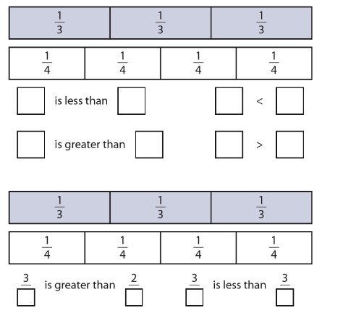 | - ‘Higher score’ in standardised tests.  - Reasoning and explain using age appropriate mathematical vocabulary precisely (eg, if I know 12 x 2 = 24 I know 13 x 2 = 26 because it is 1 lot of 2 more).  - Make connections between different aspects of the curriculum (eg, make connections between missing numbers on a scale and a number line).  - Independently use a systematic approach to problem solving.  - Solve problems of greater complexity, where the problem has more than one step.  - Explain their thinking to others.  - Represent answers clearly in a variety of ways.  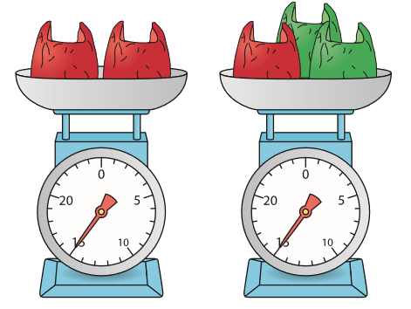  - Eg, ‘What is the mass of the two red bags? Which is heavier the red bag or the green bag? Explain how you know.’

