Year 3/4 Work Summer WB 29/06/20
Daily activities
- Reading (20 mins) – Continue reading or listening to Harry Potter or read something you have at home.
- Spelling (15 mins) – practise then choose 2 of the words from the box below and write them in a sentence.
- Maths (15 mins) – a task from the fluency ladder – only move onto the next step when you are an expert! Ask people in your house to test you on a Friday (and maybe you could test them too!). Also keep practicing your times tables on TTRockstars.
- Mindfulness – (10 mins)Try some mindful movement. Use you noticing and focusing skills. Think about what you can hear smell and feel.
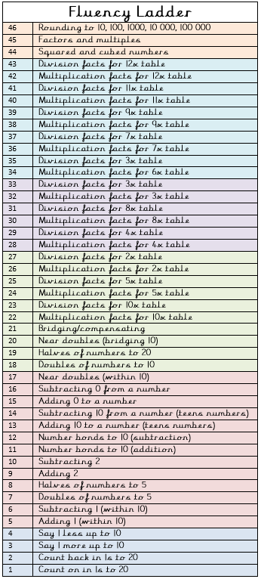
Physical activity – Can you create your own hurdle racetrack. Challenge your family to a race and see who is the fastest.

Spellings for week beginning 29.06.20
accident | arrive
actual | believe
address | bicycle
answer | breath
appear | breathe

Weekly fun task

Bubble wands.

Can you create your own bubble wands? Experiment with different shapes and sizes to find the best wand to create the biggest bubble.

Use washing up liquid and water to create your bubble mixture.

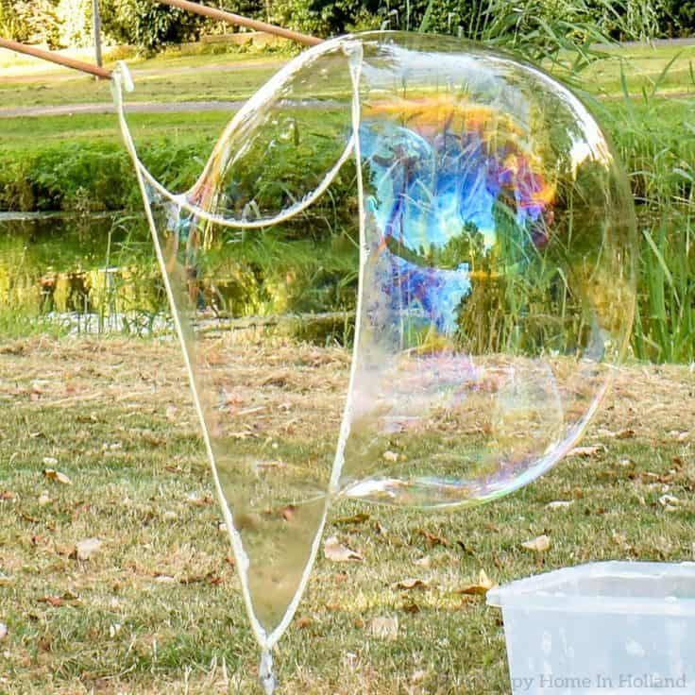
- Don’t forget to check class dojo for more fun things to do.

